
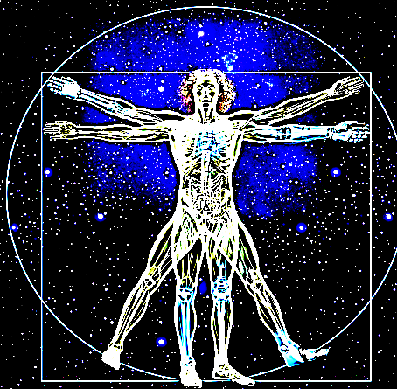

MINISTRY OF HEALTH OF THE REPUBLIC OF UZBEKISTAN
BUKHARA STATE MEDICAL INSTITUTE

ASSOCIATION OF MORPHOLOGISTS OF UZBEKISTAN

ONLINE SCIENTIFIC AND PRACTICAL CONFERENCE WITH INTERNATIONAL PARTICIPATION

INVITATION AND PROGRAM
«MODERN MORPHOLOGY AND MEDICINE»
Opening on may 15, 2020 at 10: 00
Connect to the Zoom conference
https://us02web.zoom.us/j/82955130904?pwd=OHhsS3JDTVR6eFBjdDRhQ0p2c3VsZz09
The conference ID: 829 5513 0904
Password: Bukhara
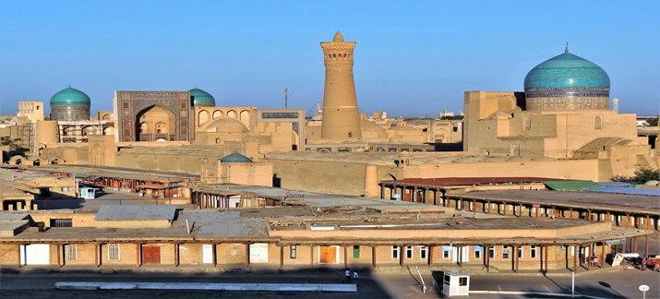

Program of the conference

PRESIDIUM:
Inoyatov A.Sh. Rector of the Bukhara state medical Institute, professor
Shamirzaev N.H. Chairman of the Association of morphologists of the Republic of Uzbekistan, professor

Conference opening
10.00-10.10  Inoyatov A. Sh.  Bukhara,  Uzbekistan | Opening speech
10.10-10.20  Shamirzaev N. H.  Tashkent,  Uzbekistan | Welcome speech

PLENARY SESSION
10.20-10.30  Teshaev Sh. Zh.,  Radzhabov A. B.  Bukhara,  Uzbekistan | History of development of morphological departments of the Bukhara state medical Institute
10.30-10.40  Shamirzaev N. H.,  Gulmanov I. J.  Tashkent,  Uzbekistan | Morphological features of the development of experimental pneumonia.
10.40-10.50  Sazonov S.V.,  Yekaterinburg,  Russia | Modern digital histology through the eyes of medical university students
10.50-11.00  Nikonova L.G. Moscow,  Russia | Morphological changes in the pancreas in the formation of dynamic endurance of the organism in experiment
11.00-11.10  Haribova E. A.  Moscow,  Russia | Age-related changes in the histoarchitectonics of goblet cells in different parts of the colon
11.10-11.20  Baymuradov R. R.  Bukhara,  Uzbekistan | Morphofunctional parameters of testes of white rats in normal, under the radiation and exposure to antiseptician stimulator - ASD-2
11.20-11.30  Mirzamuhamedov O. K.  Tashkent,  Uzbekistan | Some morphological changes of the heart on the background of hypothyroidism
11.30-11.40  Zhuraeva G. B.  Bukhara,  Uzbekistan | The particularities microhemocirculation in bud under experimental sharp intestine impassability
11.40-11.50  Khasanova D. A.  Bukhara,  Uzbekistan | Morphogenesis of Payer's patches of rat's small intestine under the influence of antiseptic – stimulator Dorogov fraction 2 on the background of chronic radiation sickness.
11.50-12.00 Abdullayeva M. A.  Bukhara,  Uzbekistan | Dynamics of indicators of immune status and endothelial function in patients with non-specific aorto-arteritis on the background of combined therapy.
12.00-12.10 Hodorova I.  Košice,  Slovakia | Macroanatomy of Payer's patches of rat's small intestine  under the influence of antiseptic – stimulator  on the background of ChRS.
12.10-12.20  Kamalova Sh. M.  Bukhara,  Uzbekistan | Comparative characteristics of morphometric parameters of children in normality and with scoliosis
12.20-12.30  Temirova N.R.  Bukhara,  Uzbekistan | Characteristics of morphometric and ultrasound features of the thyroid gland in children with endemic goiter
12.30-12.40  Саноев Б.А.  Бухара,  Узбекистан | Morphological changes that occur in secondary placental insufficiency
12.40-12.50  Ismatova M. I.  Bukhara,  Uzbekistan | Comparative characteristics of morphometric parameters of athletes involved in rhythmic gymnastics
12.50-13.00  Oripova F. Sh.  Bukhara,  Uzbekistan | Morphological picture of the effectiveness of new drugs for the treatment of nonspecific vaginitis (clinical and experimental study)
13.00-13.10  Turdiev M.R.  Bukhara,  Uzbekistan | Morphological parameters of structures of the spleen of white rats in normal and on the background of chronic radiative disease
Discussions, questions
Adoption of the conference resolution

